**Implementation of code. We got the outputs are:-**

Output:

OUTPUT SCREENSHOTS

Note:

For a voice assistant all the input and outputs are oral. These are the screenshots of those oral input and outputs displayed on interface screen (GUI).

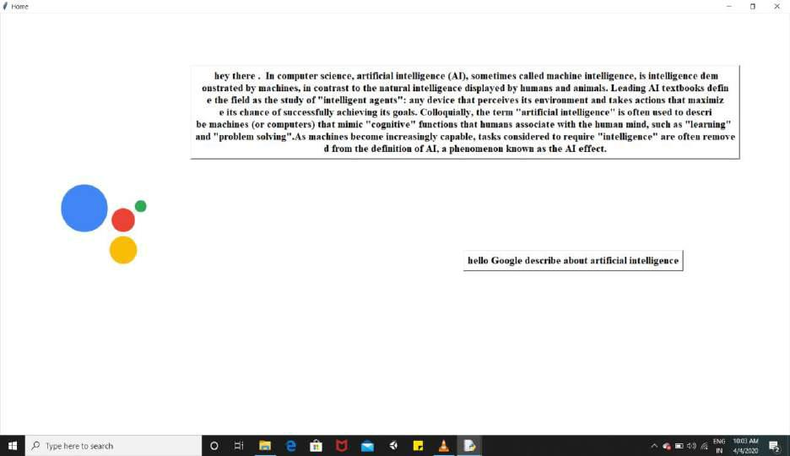

Describing about requested topic

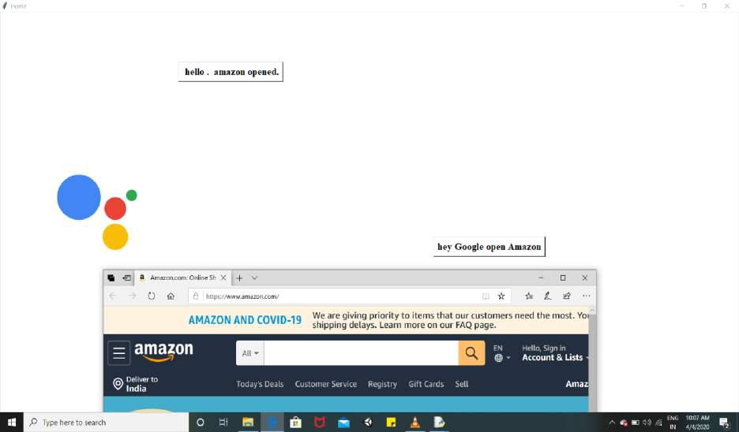

Opening applications on user’s oral command

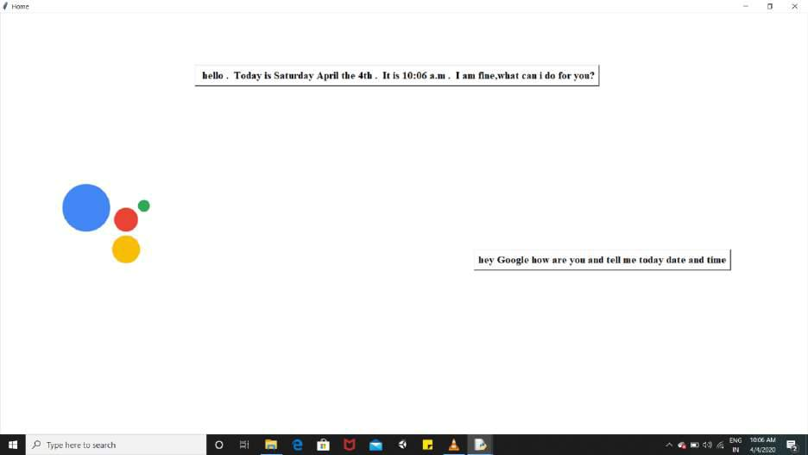

Telling Time and Date

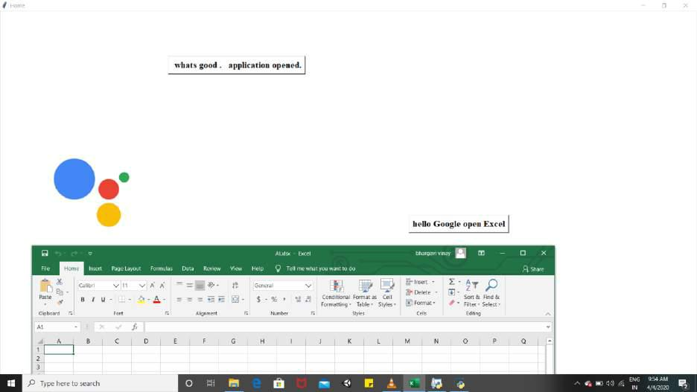

Opening Desktop Applications like word, power point, excel etc.,

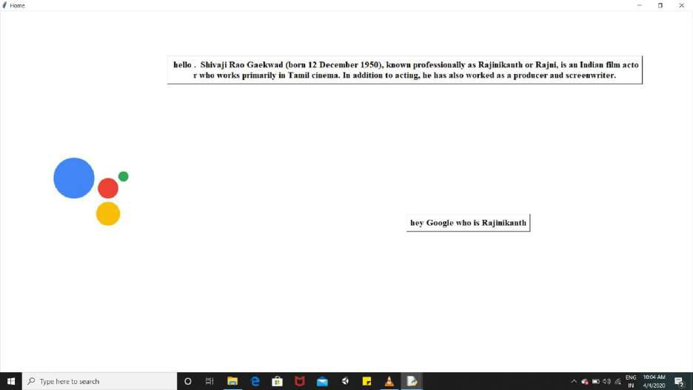

Telling Information about persons, places etc.,

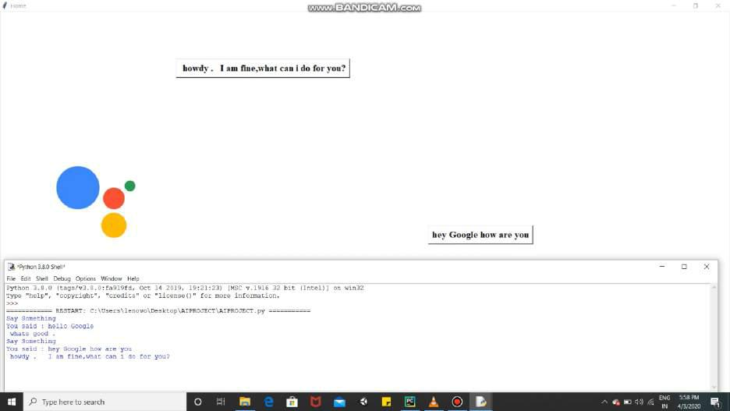

Replying for greetings.